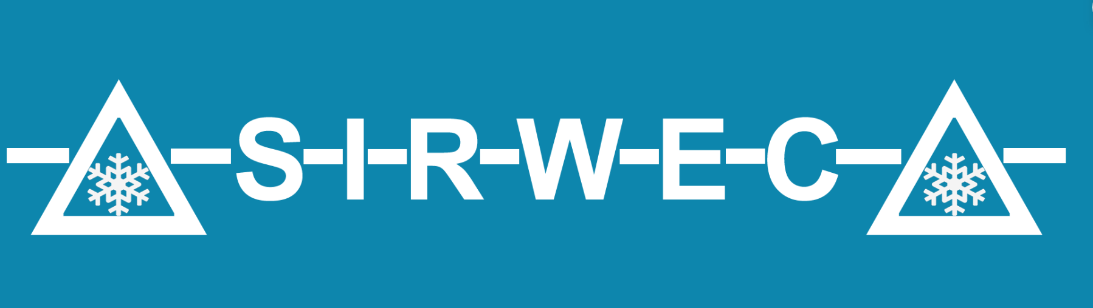
SIRWEC 2026 ABSTRACT TEMPLATE

Please fill in the details below and email to SIRWEC2026@gmail.com

NAME:

AFFILIATION:

EMAIL:

ABSTRACT TITLE:

Please write your abstract here (maximum 300 words)

Deadline is 28th November 2025

Any questions, reach out to us on SIRWEC2026@gmail.com

